# Section A

## Question 1

## 1.1

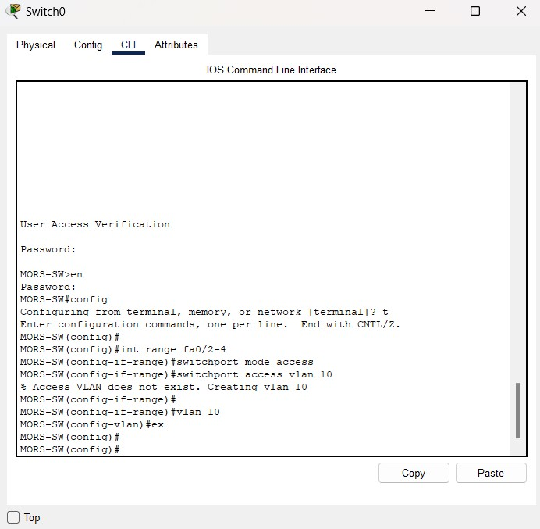

## 1.2

|  |  |  |  |  |
| --- | --- | --- | --- | --- |
| **Department** | **Network Address** | **Subnet Mask** | **Host Address Range** | **Broadcast Address** |
| **MORS** | 190.128.100.0 | 255.255.128.0/17 | 190.128.100.1 to 190.128.101.254 | 190.128.100.255 |
| **EMR** | 190.128.101.0 | 255.255.128.0/17 | 190.128.101.1 to 190.128.102.254 | 190.128.101.255 |
| **PRM** | 190.128.102.0 | 255.255.128.0/17 | 190.128.102.1 to 190.128.103.254 | 190.128.102.255 |
| **CS** | 190.128.103.0 | 255.255.128.0/17 | 190.128.103.1 to 190.128.104.254 | 190.128.103.255 |
| **IT** | 190.128.104.0 | 255.255.128.0/17 | 190.128.104.1 to 190.128.105.254 | 190.128.104.255 |
| **Server-Side** | 190.128.105.0 | 255.255.128.0/17 | 190.128.105.1 to 190.128.106.254 | 190.128.105.255 |
| **Multilayer Switch** | 190.128.106.0 | 255.255.128.0/17 | 190.128.106.1 to 190.128.107.254 | 190.128.107.255 |

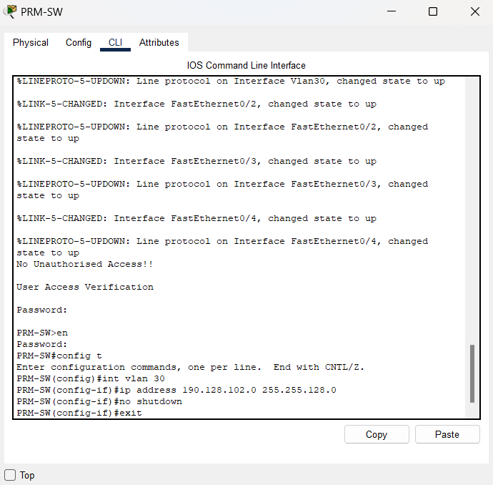

## 1.3

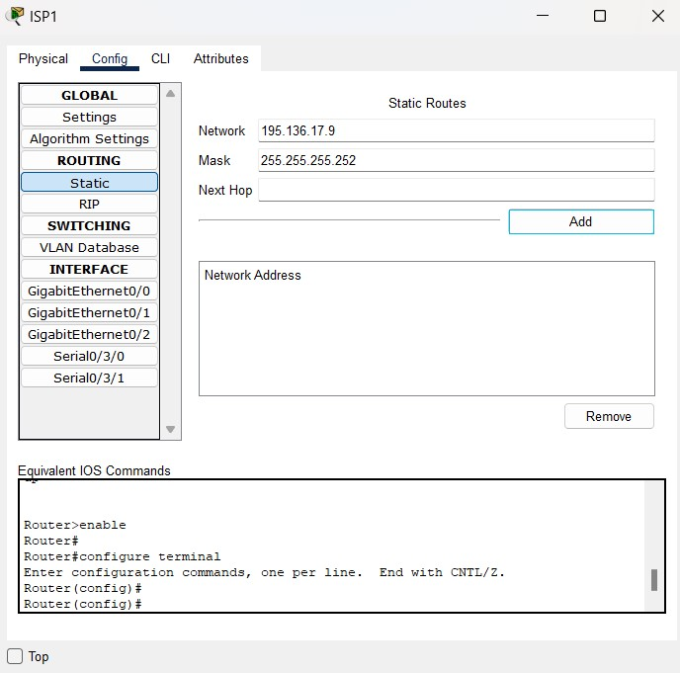

## 1.4

## 1.5

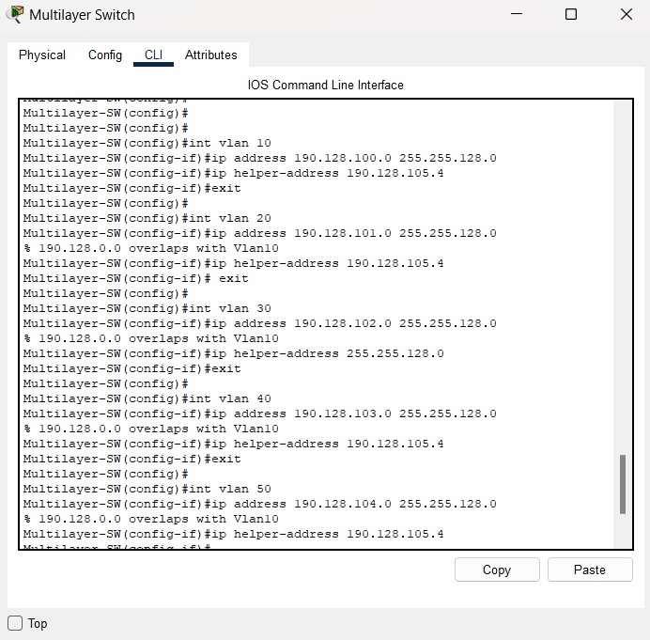

## Question 2

2.1

2.2 **Static IP allocation for devices in server room**

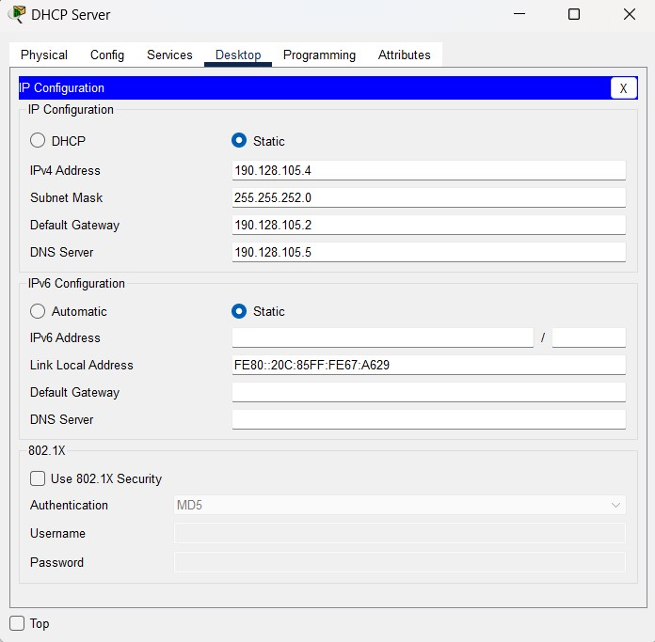

2.3

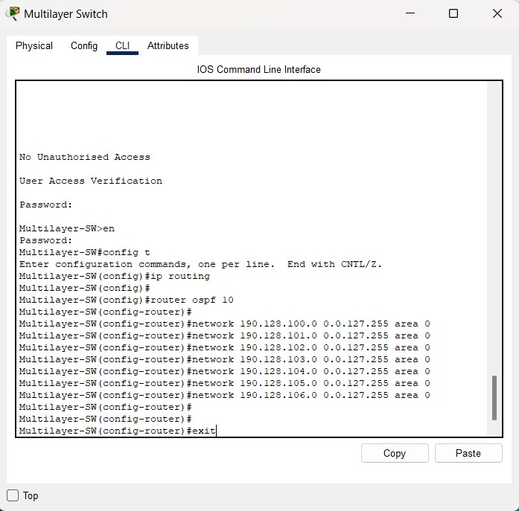

2.4

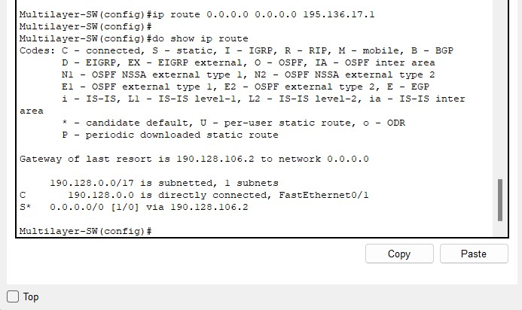

## Question 3

## 3.1

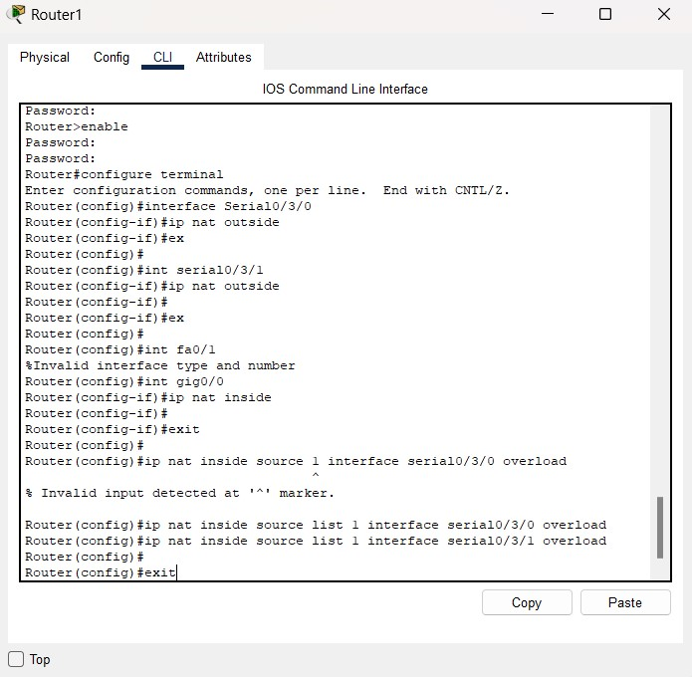

## 3.2

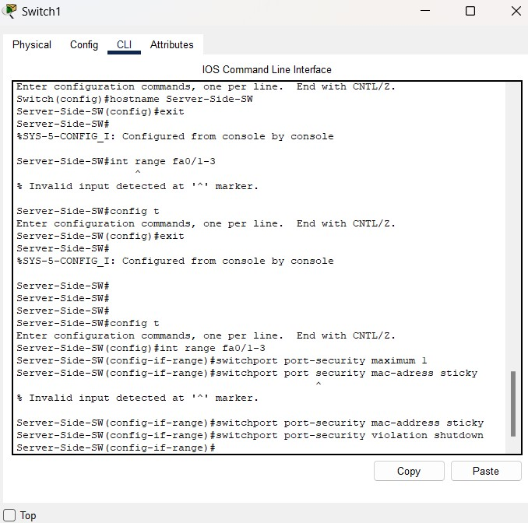

## 3.3

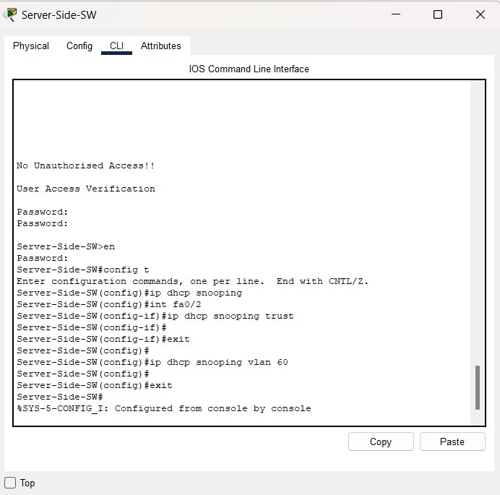

## 3.4

## 